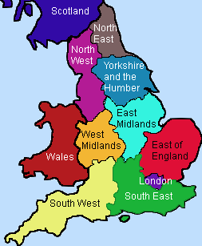

Other information:

Who was involved? (Names, groups, occupations)

What happened?

Aims?

Questions you have:

Where did it take place?

Outcomes/results?

Motive/causes?

**What happened in England in 1381?**